**CHAPTER 2 Working of services**

**Amazon lex**

**User** - The user interacts with the AWS Lex bot and starts the conversation by using the Sample Utterances to invoke with the “Greetings” Intent. And based on information it gathers the information from the user on patient details.

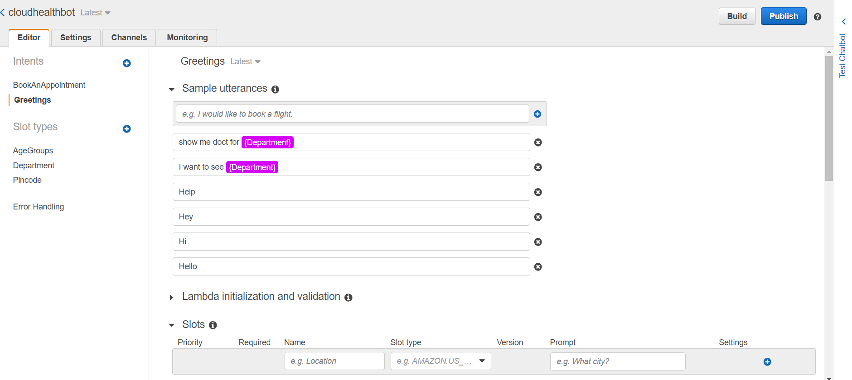

**Lex** - The Lex bot has 2 intents namely Greetings and BookAnAppointment. The first intent to get invoked is “Greetings”.

* Greetings: The main purpose of this intent is to know the details of the patient and refer to the medical Department that the user needs to base on the answers given by the user.
* BookAnAppointment: The use of this intent is to Book the appointment for the user after the user has choose the doctor they want to see.

**Lambda** - Lambda is an integral part of this project as it has the job of fetching the data from the DynamoDB based on the medical Department inferred by the bot.

Another purpose of the the lambda function is to determine the flow of the conversation and handling the intent switching. lambda function is written in **Python** and The **IAM Roles** given to the lambda function

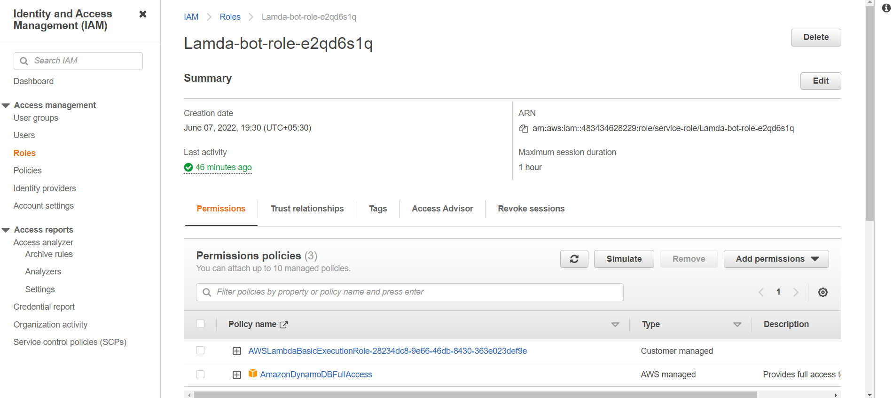

**DynamoDB** - It is the database that is used to store the information about the doctors and which area are they based in.

There are three main regions are Vizag, Khammam, Nalgonda. There are 3 medical departments which are:

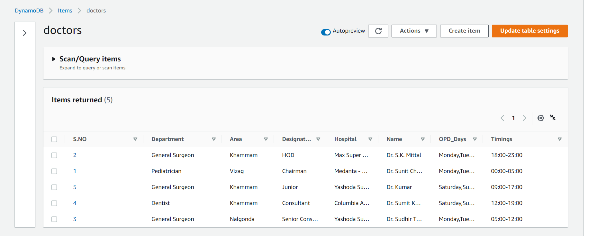

**The index used to search the DynamoDB are:**

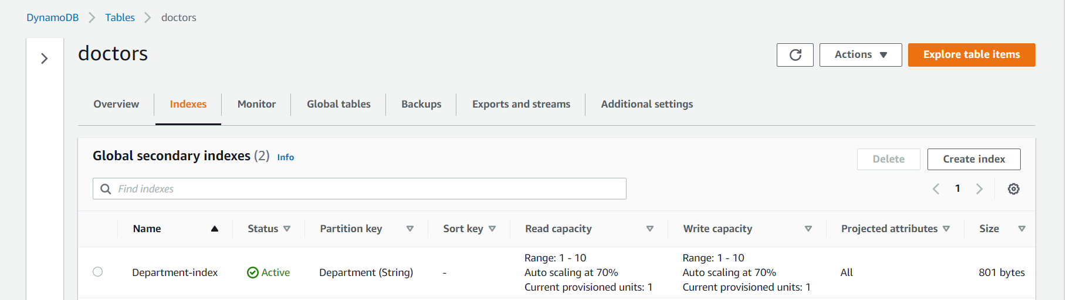

**Slots and Slotypes used in AWS Lex:**

**Greetings:** The slots and slotypes in this intent used are:

**FirstName:** This is the slot that asks and stores the first name of the patient. The SlotType used here is amazon.us_first_name which is a built-in slot type in amazon lex.

**Age:** This stores the age of the patient and uses a custom SlotType Age Groups.

**Pincode:** This stores the age of the pin code and uses a custom SlotType Pincode.

**Department:** This stores the age of the pin code and uses a custom SlotType Pincode.

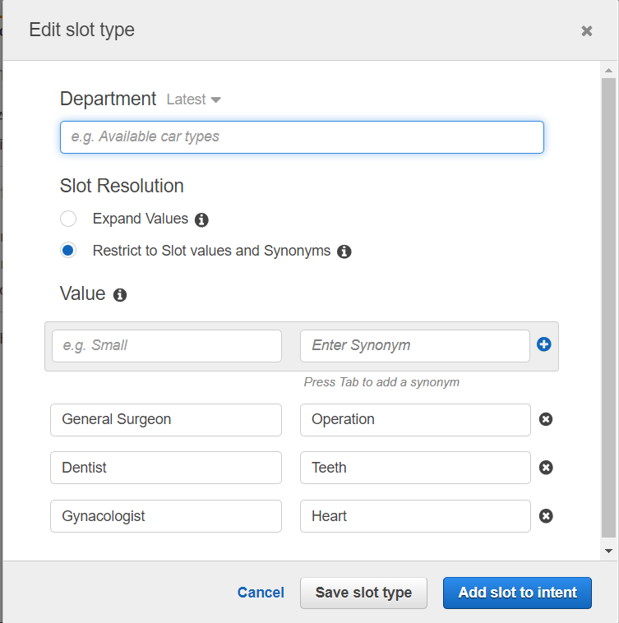

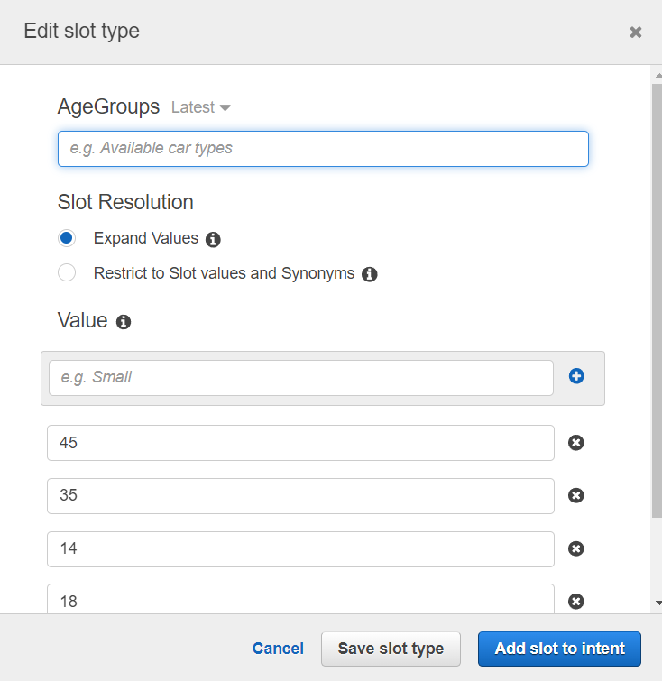

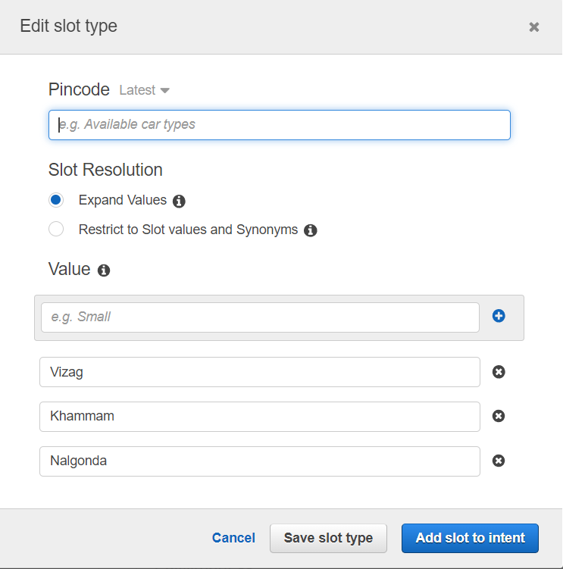

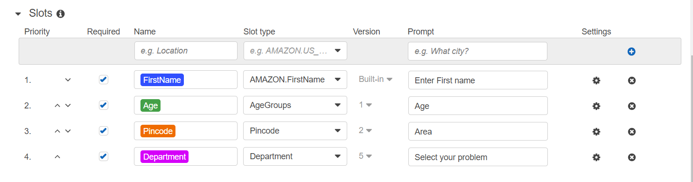

**BookAnAppointment:** The intent that accompanies the Greetings intent was this. After the Greetings intent is completed, it displays a response Card with the names of the doctors separated by regions and distance. And this intent will wait for the user to select a doctor from the answer card's list of possibilities.

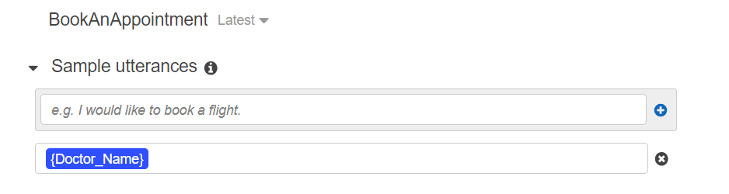

**Doctor_Name**: This slot is in capable of waiting for the doctor to be chosen and saving the doctor's name for later usage in the current Intent. It uses a custom-built slot Type Doctor_Name.

**Confirmation_Status**: After providing further information about the doctor that the patient has selected, this slot takes in the confirmation in yes or no. It uses a custom-built slot Type Confirmation_status.

**OPD_days:** This contains the user-selected day in relation to the doctor's OPD Days. This uses a custom built slotType called OPD_Days.

